SA-1 – State Aid Advance $ 49,473,950
Calculation:
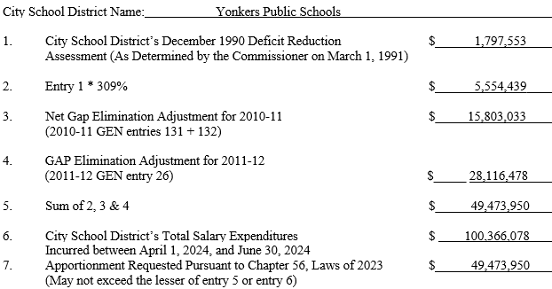
History
- In 1990, a mid-year aid adjustment resulted in deficits for some districts. In turn, the state passed legislation to provide districts an advance of the upcoming school year State Aid and claim it as revenue for the current year. The solution took care of the issue in 1990, but in turn the districts experienced shortfalls in future years
- As a result the state passed additional funding Up to a maximum of 1990 Deficit Reduction Assessment (1,797,553) plus 209% of such amount (3,756,886) for a total of $5,554,439 which is equal to Entry 1 multiplied by 309%
- Once GEA came along the language was added to allow for those amounts to be included in the potential advance as well 1990 Deficit Reduction Assessment
- The form is for the advance of the 1990 mid-year-adjustment, the 2010-11 & 2011-12 GAP elimination adjustment.
- If we do not complete advance request it will impact our 2023-24 revenue and cash flow by $49,473,950
- This form cannot be submitted to the state no sooner than June 10 and no later than June 21. This is an issue for the school district because it requires board approval. The BOE June stated meetings always fall just before the due date.
Language of the Law
Chapter 56 of the Laws of 2023 provides an apportionment to city school districts for salary expenses incurred between April 1, 2024, and June 30, 2024, up to a maximum amount equal to the city school district’s Deficit Reduction Assessment of December 1990 plus 209 percent of such amount for a city school district in a city with a population of more than 195,000 inhabitants and less than 219,000 inhabitants according to the latest federal census plus the Gap Elimination Adjustments for 2010-11 and 2011-12. Upon application, this apportionment is available to the city school district as revenue to the 2023-24 school year and may be used to offset any potential General Fund deficit as of June 30, 2024, resulting from the impact upon city revenues of the Deficit Reduction Assessment and the Gap Elimination Adjustments for 2010-11 and 2011-12. The apportionment will be paid in September 2024, and this amount will be deducted from the following payments in the following order: The Lottery apportionment followed by the fixed fall payments (October, November, December 2024, for the 2024-25 school year), followed by the district’s payments to the Teacher’s Retirement System. Any remainder will be deducted from the individualized payments due the district (January – June 2025 General Aid).

