Public Pension Accrual - $15,035,166
Calculation
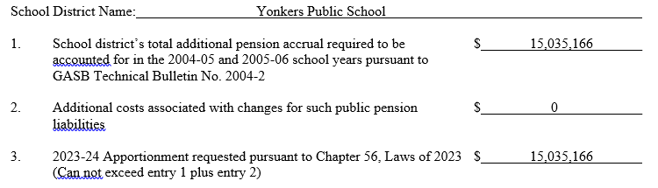
History
- In 2004-2005, the change in pension law resulted in a deficit for school districts.
- In turn, the state passed legislation to provide districts an advance of the upcoming school year State Aid and claim it as revenue for the current year.
- If we do not complete advance request it will impact our 2023-24 revenue and cash flow by $15,035,166.
- The deadline is June 30th
Language of the Law
Chapter 56 of the Laws of 2023 provides for an apportionment to school districts for public pension accruals required to be accounted for in the 2004-05 and 2005-06 school years and associated with changes for such public pension liabilities. Upon application, this apportionment is available to the school district as revenue to the 2023-24 school year and may be used to offset any General Fund deficit as of June 30, 2024 resulting from the impact upon school district revenues of these additional pension accruals. The apportionment will be paid in September 2024, and general aid payable during the 2024-25 school year will be reduced in an amount equal to the apportionment in the following order: The lottery apportionment followed by the fixed fall payments, and then followed by the district’s payments to the teachers’ retirement system, and any remainder will be deducted from the individualized payments due the district.

