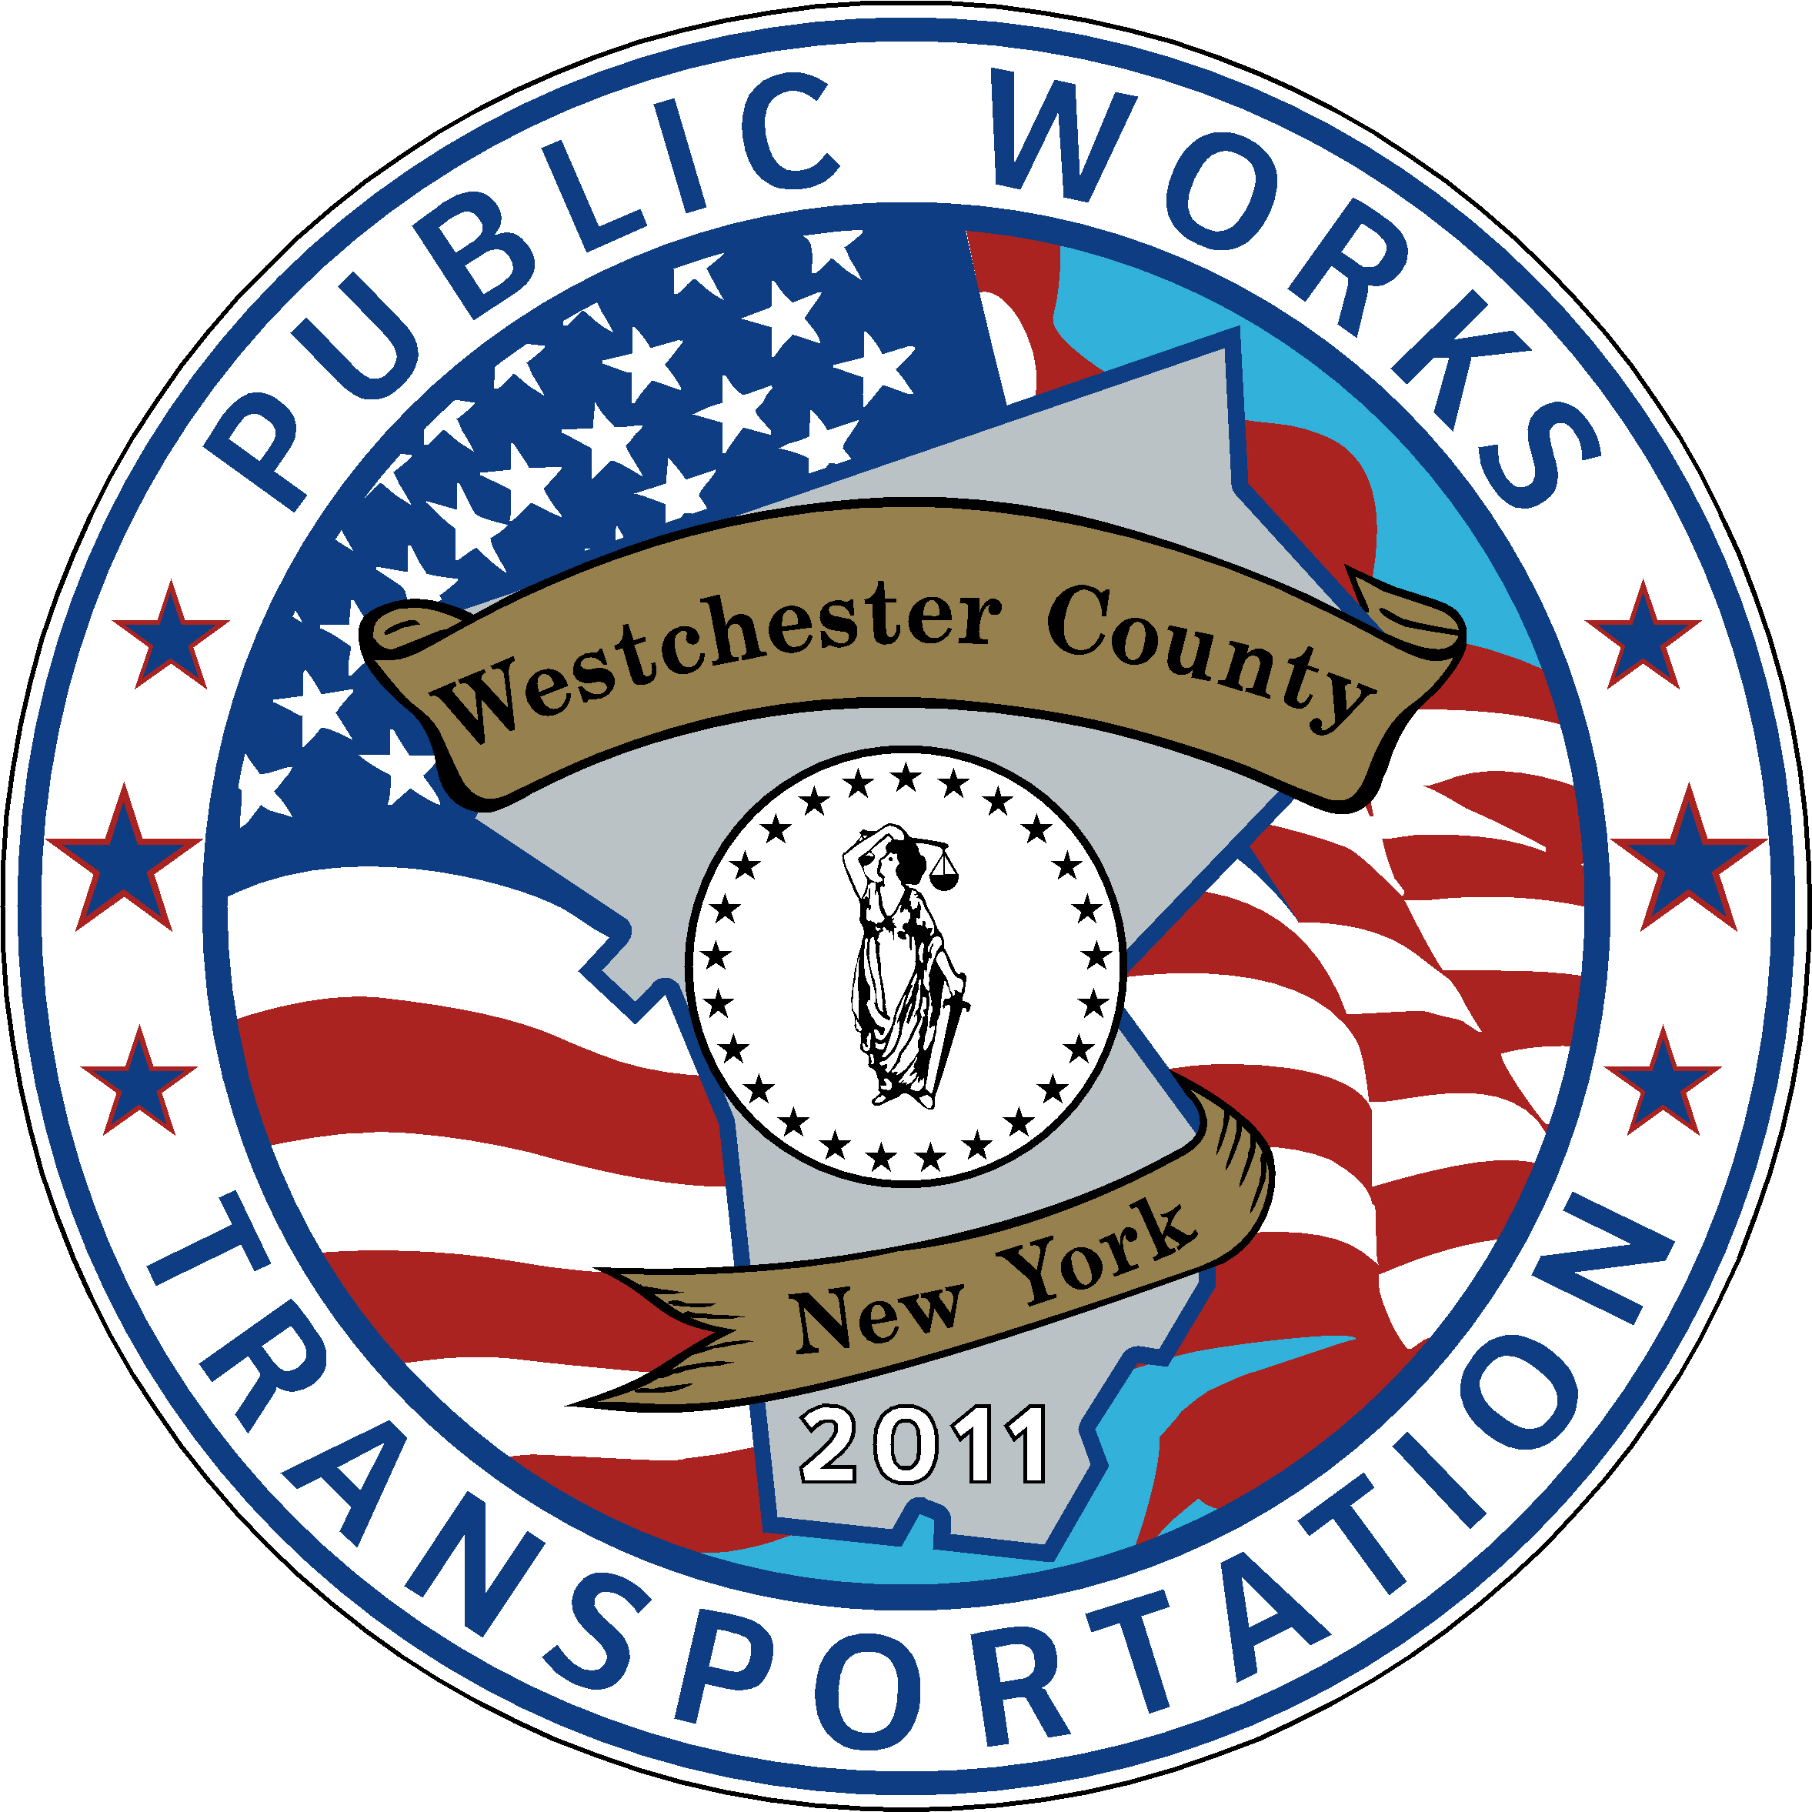

Invoice Number: 2024-6-YPS
Invoice Date: 6/4/24

Bill to: Yonkers Public Schools
ATTN: Jinjuta Phothipraisiri

1-Trip MetroCard –30,000 qty

30,000 @ $2.90 ea. $87,000

Balance Due $87,000

Terms: Payment due upon receipt



